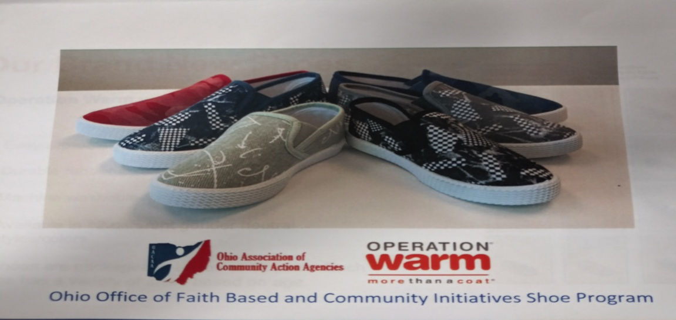
Clinton County Community Action Program Inc.
is giving away shoes to families in need.
The shoes are the style shown above and are available in 12 different colors.
The shoes come in neutral colors so they are for boys or girls.
The shoes come in the following sizes:
Pre-K – sizes 8, 9, 10
Kindergarten – sizes 11, 12, 13
Grades 1-2 – sizes 1, 2, 3
Grades 4, 5, 6 – sizes 4, 5, 6
The family requesting service includes a parent or relative of a dependent child under 18 (or under 19 who is still a full-time student in high school or at the equivalent level of vocation or technical training), who has never been married, and the child lives in the home. Using the chart below, determine if the household income is at or below 200% of the 2020 Federal Poverty Level limits.
Number in Household | Monthly
1 | $2127
2 | $2874
3 | $3620
4 | $4637
5 | $5114
6 | $5860
7 | $6607
8 | $7354
9 | $8100
You will need to fill out verification forms in order to receive the shoes.
Call Robin Crone at 937-283-1938 to see if your child(ren) size is still available.
Or come to the CC Community Action and ask for Robin.
789 N. Nelson Ave. Wilmington, Ohio

